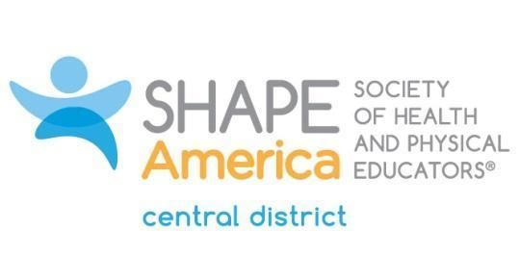

Mark L. Harvey Legacy Recognition Award
To be considered for an award, this official form must be completed in detail. Resumes or vitae will not be accepted.
A statement from one sponsor explaining the merit of the nominee's contributions must accompany this form. It is recommended that a head-and-shoulders picture be sent with the nomination.

SPONSOR
First Name:
Last Name:
Mailing Address:
Phone (H):
Phone (W):
Email:
PERSONAL DATA OF NOMINEE
First Name:
Last Name:
Mailing Address:
Phone (H):
Phone (W):
Email:
SHAPE America Membership #:
# of Years as SHAPE America Member:
EMPLOYMENT HISTORY
Present Position:
Previous Positions:
EDUCATION Institution Degree Date
High School:
Undergraduate:
Graduate:

Please provide information to complete the following requirements* and to present your contributions to the profession. Use no more than five typed pages, including the cover sheet. If more pages are submitted, the Recognition Awards Committee will use only the first five. Thank you.

*Candidates must have shown accomplishments in the following areas:
- Mentor/Caring (teacher, coach and/or administrator)
- Courage (overcome adversity)
- Leadership (involvement in state, regional and/or national professional associations)
- Stewardship (community, volunteerism and/or faith involvement)

SHAPE America Offices Held:
District:
State:
National:

SHAPE America Committee Work:
District:
State:
National:
Professional Contributions such as:
Speeches and presentations:
Writing and research:
Choreography and creative activity:
Other Professional Educational Endeavors:
Community Relationships and Services:
Honors Received:

Email the application and photograph, along with a letter from the sponsor, to:
Deb Stephenson: stephensond@sw1.k12.wy.us
Application Deadline: October 15

